# How to Run Jacoco

1. Download the JacocoDemo zip file from the rotce GitHub repository and extract it.
2. Open Eclipse and import the maven project into your workspace.
3. Take at look at Converter.java in the src/main/java folder and ConverterTest.java in src/test/java

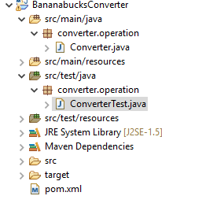

1. Right-click on the project node and select Run as a Maven Test.

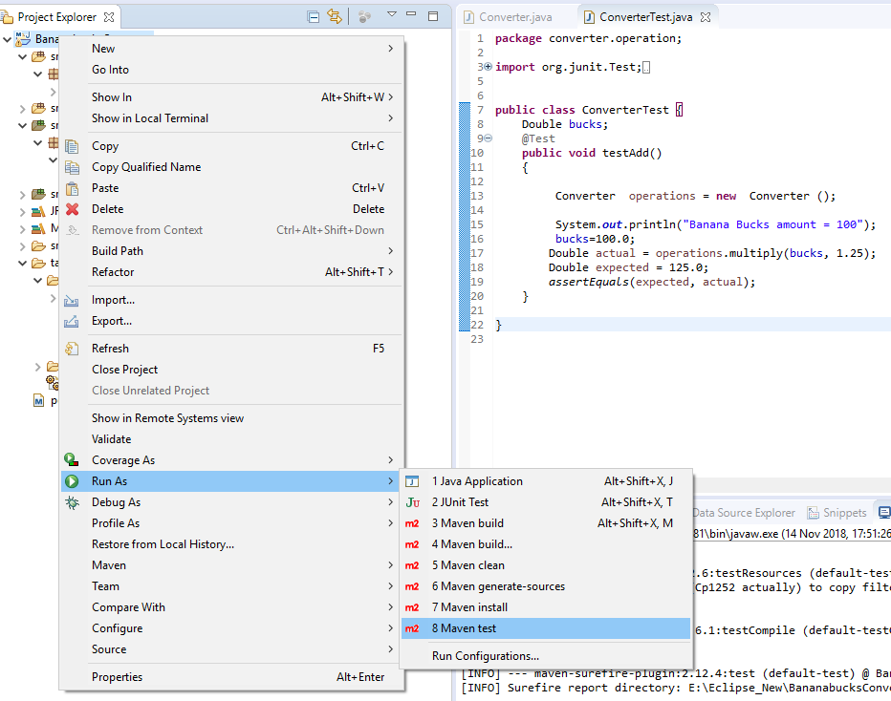

1. Once the test has completed, click on index.html in the target folder and open with eclipse’s web browser.

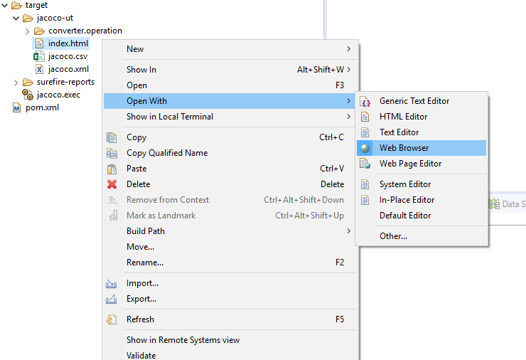

1. You should now see results of Jacoco. This tool has identified every line in the program, telling the user which methods were and were not used. This an extremely useful tool that gives developers full coverage of their code.

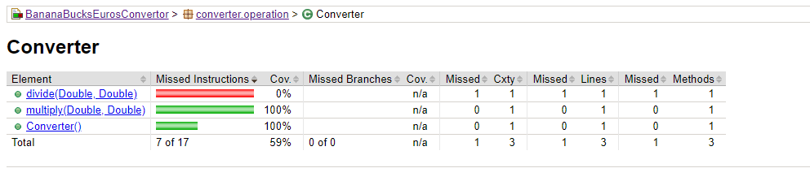

As you can see from the results, there is a red bar which means that there is a method which is not being used in the maven test. This issue should be looked at in further detail in sprint 6.